Not satisfied?

If for any reason you do not wish to liaise with staff here then you can request that the integrated care board (ICB) investigates your complaint and will contact us on your behalf:

NHS Suffolk and North East Essex integrated care board
Severalls Business Park
Stephenson Road
Highwoods
Colchester
CO49QR

Email: sneeicb.pals@nhs.net

Telephone: 01473 770000 (option 6)

If you are still dissatisfied with the outcome of your complaint from us at Mendlesham Medical group or SNEE (Suffolk and north east Essex) ICB, then you can escalate your complaint to the parliamentary Health Service ombudsman (PHSO):

Health Service Ombudsman. The contact details are:
The Parliamentary and Health Service Ombudsman
Millbank Tower
Millbank
London
SW1P 4QP
Tel: 0345 0154033
Website: www.ombudsman.org.uk

MENDLESHAM MEDICAL GROUP

Complaints Procedure and process

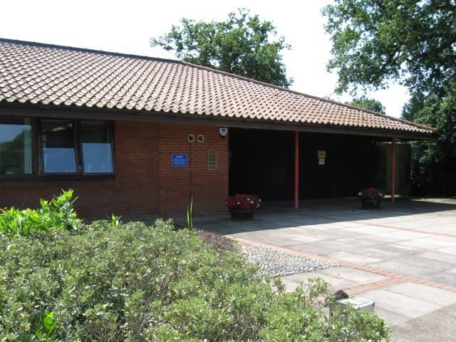

Mendlesham Health centre
Chapel Road
Mendlesham
IP145SQ

Tel: 01449 767722

Making a Complaint
Every patient has the right to make a complaint about the treatment or care they have received at Mendlesham Medical group.
We understand that we may not always get everything right and, by telling us about the problem you have encountered, we will be able to improve our services and patient experience.

Most problems can be resolved quickly and easily, often at the time of the event and this may be the approach you try first.
Where you are not able to resolve your complaint in this way and wish to make a formal complaint you should do so, preferably in writing as soon as possible after the event and ideally within a few days, as this helps us to establish what happened. In any event, this should be:
Within 12 months of the incident, or within 12 months of you discovering giving as much detail as you can.
If you are a registered patient you can complain about your own care. You are unable to complain about someone else’s treatment without their written authority (see complaining on behalf of someone else)
We are able to provide you with a separate
complaints form to register your complaint, this includes a third-party authority form to enable a complaint to be made by someone else. Please ask at reception for this. You can provide this in
your own format providing this covers all the
necessary aspects.

What we do next
We look to resolve complaints as soon as possible.
We will acknowledge receipt within 3 working days, and aim to have looked into the matter within 10 working days. You may then receive a formal reply in writing, or you may be invited to meet with the person(s) concerned to attempt to resolve the issue. If the matter is likely to take longer than this we will let you know, and keep you informed as the investigation progresses.
When looking into a complaint we attempt to see what happened and why, to see if there are any learning outcomes, and make it possible for you to discuss the issue with those involved if you wish to do so.
When the investigations are complete your complaint will be determined and a final response sent to you.
Where your complaint involves more than one organisation (e.g. social services) we will liaise with that organisation so that you receive one coordinated reply. We may need your consent to do this. Where your complaint has been sent initially to an incorrect organisation, we may seek your consent to forward this to the correct person to deal with.
The final response letter will include details of the result of your complaint and also your right to escalate the matter further if you remain dissatisfied with the response.

Complaining on Behalf of someone else
We adhere to the strict rules of medical and personal
confidentiality. If you wish to make a complaint and are not the patient involved, we will require the written
consent of the patient to confirm that they are
unhappy with their treatment and that we can deal with someone else about it.
Please ask at reception for the Complaints Form which contains a suitable authority for the patient to sign to enable the complaint to proceed.
Where the patient is incapable of providing consent due to illness or accident it may still be possible to deal with the complaint. Please provide the precise details of the circumstances which prevent this in your covering letter.
Please note that we are unable to discuss any issue relating to someone else without their express
permission, which must be in writing, unless the circumstances above apply.
We may still need to correspond direct with the patient, or may be able to deal direct with the third party,
and this depends on the wording of the authority
provided.

Send your written complaint to:

Practice Manager
Mendlesham Health Centre
Chapel Road
Mendlesham
IP14 5SQ
Or email us at: mmg.mendlesham@nhs.net

